In-silico Identification and Functional Characterization of a Hypothetical Protein (B0RC17) from Clavibacter sepedonicus using Homology-Based Annotation.
The central question of this project was how an unknown or hypothetical protein sequence can be computationally analyzed to assess its quality, identify homologous sequences, and predict its biological function. The results obtained across the pipeline demonstrate that systematic sequence analysis and homology-based annotation can reliably infer the likely function of an uncharacterized protein.
PROJECT PIPELINE:
This project focuses on the in-silico analysis and functional characterization of a protein sequence using a dependency-based bioinformatics pipeline, where each step depends on the successful completion of the previous one:
1. Sequence Retrieval
2. Sequence Quality & Basic Analysis
3. Sequence Filtering & Validation
4. Homology Search (BLAST)
5. Functional Annotation
6. Biological Interpretation
PROJECT STRUCTURE:
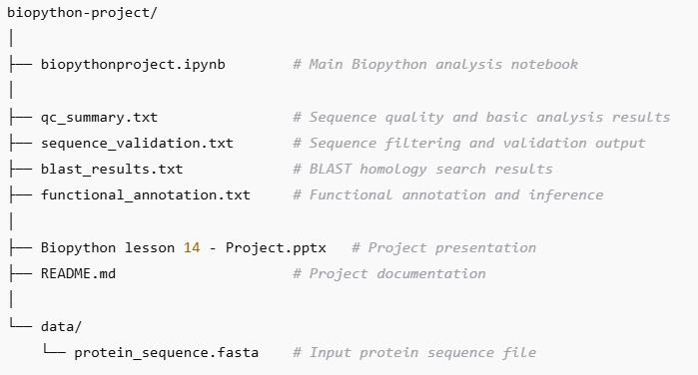

TOOLS USED IN THIS PROJECT:
- Python
- Biopython
- Jupyter Notebook
- NCBI BLAST (BLASTp)
- NCBI Protein Database
- UniProt Database .
STEPS AND INTREPRETATION FOR THE QUERY PROTEIN:
CORE EXPLANATION AND REASONING:

Step 1: Biological Sequence Selection
The selected protein sequence (UniProt ID: B0RC17) was initially annotated as a conserved hypothetical protein from Clavibacter sepedonicus. Choosing a hypothetical protein is scientifically relevant because such sequences lack experimentally validated functions, making them ideal candidates for in-silico functional prediction. This establishes a clear research problem rather than a tool-driven analysis.

Step 2: Sequence Quality & Basic Analysis
The protein sequence length was 379 amino acids, which falls within the expected range for functional bacterial enzymes. Amino acid composition analysis showed a biologically reasonable distribution without abnormal enrichment or depletion of residues. This indicates that the sequence is structurally plausible and not an artifact, justifying further downstream analysis.

Step 3: Sequence Filtering & Validation
The sequence passed all validation criteria, including minimum length requirements and absence of ambiguous amino acids. This decision point is crucial, as it confirms that the sequence quality is sufficient for reliable homology search and functional annotation. Proceeding with a validated sequence reduces the risk of false functional predictions.

Step 4: Homology Search (BLAST)
BLAST analysis revealed highly significant matches to alkaline phosphatase family proteins from multiple Clavibacter species. The alignment covered the full length of the query sequence with an E-value of 0.0 and extremely high bit scores. These results strongly indicate evolutionary conservation and suggest that the query protein shares a common ancestry and function with known alkaline phosphatases.

Step 5: Functional Annotation
Based on 100% sequence identity with the top BLAST hit and consistent annotation across related species, the protein B0RC17 is predicted to belong to the alkaline phosphatase family. Alkaline phosphatases are typically involved in phosphate metabolism and play important roles in bacterial survival and adaptation. This functional inference is supported by strong homology evidence, although it remains computationally predicted.

Step 6: Biological Interpretation
Overall Conclusion:
Integrating sequence quality analysis, validation, homology search, and functional annotation, this study predicts that the previously hypothetical protein B0RC17 functions as an alkaline phosphatase family protein in Clavibacter sepedonicus. The consistency of results across the pipeline demonstrates how bioinformatics approaches can transform an uncharacterized sequence into a biologically meaningful prediction. While experimental validation is required for confirmation, this in-silico pipeline provides strong evidence for the proposed function .

Final Project Outcome :
This project demonstrates that an unknown protein sequence can be systematically analyzed, validated, compared with known sequences, and functionally annotated using computational tools. The study highlights the power of homology-based inference in bioinformatics and illustrates how raw sequence data can be translated into biological insight.

